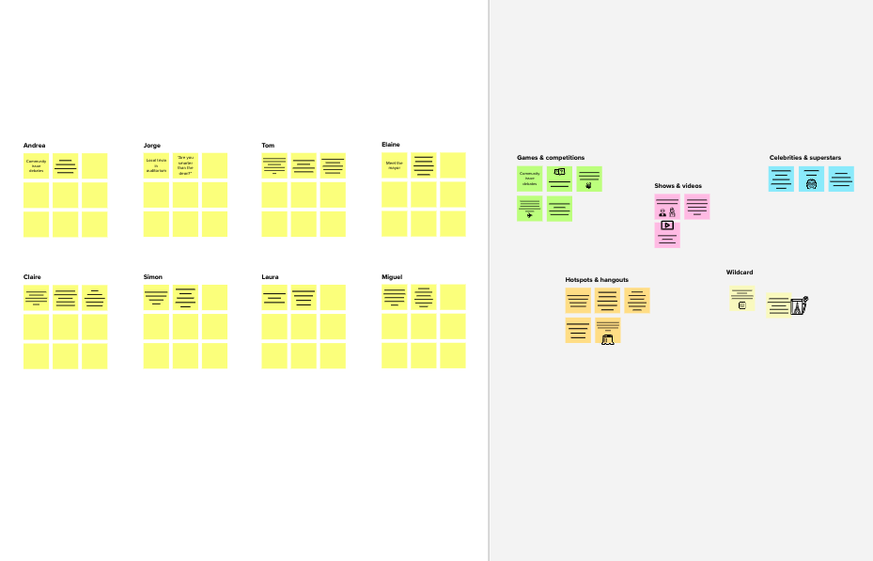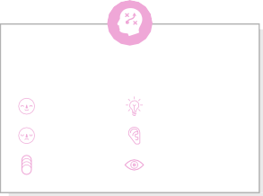

# Brainstorm

**TIP**

You can select a sticky note and hit the pencil [switch to sketch] icon to start drawing!

**TIP**

Participants can use their cursors to point at where sticky notes should go on the grid. The facilitator can confirm the spot by using the laser pointer holding the **H key** on the keyboard.

### Before you collaborate

##### A little bit of preparation goes a long way with this session. Here’s what you need to do to get going.

###### 10 minutes

**1**

### Define your problem statement

##### What problem are you trying to solve? Frame your problem as a How Might We statement. This will be the focus of your brainstorm.

###### 5 minutes

**2**

### Brainstorm

##### Write down any ideas that come to mind that address your problem statement.

**10 minutes**

**3**

### Group ideas

##### Take turns sharing your ideas while clustering similar or related notes as you go. Once all sticky notes have been grouped, give each cluster a sentence-like label. If a cluster is bigger than six sticky notes, try and see if you and break it up into smaller sub-groups.

###### 20 minutes

**4**

### Prioritize

##### Your team should all be on the same page about what's important moving forward. Place your ideas on this grid to determine which ideas are important and which are feasible.

**20 minutes**

### After you collaborate

You can export the mural as an image or pdf to share with members of your company who might find it helpful.

# & idea prioritization

Use this template in your own brainstorming sessions so your team can unleash their imagination and start shaping concepts even if you're not sitting in the same room.

1. Team gathering

Define who should participate in the session and send an invite. Share relevant information or pre-work ahead.

1. Set the goal

Think about the problem you'll be focusing on solving in the brainstorming session.

1. Learn how to use the facilitation tools

Use the Facilitation Superpowers to run a happy and productive session.

Late comers to go without ticket, they paid some extra amount to buy ticket from TTR

**Smart Solutions For Railways**

**PROBLEM**

**Reduce the word load of the user and also the use of paper**

jawahar

Availability of medical team in every train

**TIP**

Add customizable tags to sticky notes to make it easier to find, browse, organize, and categorize important ideas as themes within your mural.

Provide first aid kit to every compartment

Give pass/ card to the regular passengers

Provide helpline number for passengers medical issues

Next station name displays in every compartment

User can use machine to book tickets in every station (like an ATM machine to reduce the paper size)

Separate compartments with respect to places

Late comers to go without ticket, they paid some extra amount to buy ticket from TTR

Make food ordering facilities to the passengers whatever they want from the available list

**Manoj kumar**

## 

Give alerting sound for safety purpose of doorstep passengers

Give lockers to hold expensive things for long distance travelers and lockers can be arranged in separate compartments

Displaying or sound alerting for side by beautiful places like falls, hills, etc. for improving passengers

viewing experience

Provide first aid kit to every compartment

Take safety measures in the station platform to avoid standing near railway tracks

**srinivasan**

## 

General compartment passengers get ticket from machine

Set camera in every compartment to find robbers

Reduce collection the unwanted informations while ticket booking

Intimate arriving station name using speakers

Train stopping time in station is intimated in every compartments

**Abdul kiyas**

## 

Extend the time limit of general compartment tickets

Give some digital device (tab) to display passenger detail to the replacement of paper verification

Display map in every compartment

Showing passenger seating allotment in every compartment

Availability of medical team in every train

Ticketing ideas

## 

General compartment passengers get ticket from machine

Spot ticketing from TTR

User can use machine to book tickets in every station (like an ATM machine to reduce the paper size)

#### Quick add-ons

* 1. Share the mural

**Share a view link** to the mural with stakeholders to keep them in the loop about the outcomes of the session.

* 1. Export the mural

Export a copy of the mural as a PNG or PDF to attach to emails, include in slides, or save in your drive.

**10 minutes** to prepare

**1 hour** to collaborate

**2-8 people** recommended

[**Open article**](https://support.mural.co/en/articles/2113740-facilitation-superpowers)

**Sanjay M**

Give pass/ Don't fill ticket Intimating arriving

card to the forms get details station platform

regular

from passengers number to the

passengers ticket counter passengers

saying in the travelling

ticketing

Spot Provide helpline number for

from TTR medical issues

passengers

Give pass/ card to the regular passengers

Don't fill ticket forms get details from passengers saying in the ticket counter

Take safety measures in the station platform to avoid standing near railway tracks

#### Key rules of brainstorming

Provide first aid kit to every compartment

Take safety measures in the station platform to avoid standing near railway tracks

Give alerting sound for safety purpose of doorstep passengers

Give some digital device (tab) to display passenger detail to the replacement of paper verification

To run an smooth and productive session

Safety purpose

## 

Give some digital device (tab) to display passenger detail to the replacement of paper verification

Extend the time limit of general compartment tickets

#### Keep moving forward

Strategy blueprint

User can use machine to book tickets in every station (like an ATM machine to reduce the paper size)

Define the components of a new idea or strategy.

[Open the template](https://app.mural.co/template/e95f612a-f72a-4772-bc48-545aaa04e0c9/984865a6-0a96-4472-a48d-47639307b3ca)

**Customer experience journey map**

Understand customer needs, motivations, and

Stay in topic. Defer judgment.

Give alerting sound for safety purpose of doorstep passengers

Reduce collection the unwanted informations while ticket booking

General compartment passengers get ticket from machine

Set camera in every compartment to find robbers

Encourage wild ideas. Listen to others.

#### Importance

Availability of medical team in every train

Provide helpline number for passengers medical issues

If each of these

obstacles for an experience.

[**Open the template**](https://app.mural.co/template/b7114010-3a67-4d63-a51d-6f2cedc9633f/c1b465ab-57af-4624-8faf-ebb312edc0eb)

Make food ordering facilities to the passengers whatever they want from the available list

Give lockers to hold expensive things for long distance travelers and lockers can be arranged in separate compartments

Go for volume. If possible, be visual.

Set camera in every compartment to find robbers

Next station name displays in every compartment

Make food ordering facilities to the passengers whatever they want from the available list

Features to the passengers

tasks could get

done without any difficulty or cost, which would have the most positive impact?

Display map in every compartment

**Strengths, weaknesses, opportunities & threats**

Identify strengths, weaknesses, opportunities, and threats (SWOT) to develop a plan.

Late comers to go without ticket, they paid some extra amount to buy ticket from TTR

Next station name displays in every compartment

Spot ticketing from TTR

[Open the template](https://app.mural.co/template/6a062671-89ee-4b76-9409-2603d8b098be/ca270343-1d54-4952-9d8c-fbc303ffd0f2)

Don't fill ticket forms get details from passengers saying in the ticket counter

[**Share template feedback**](https://muralco.typeform.com/to/CiqaHVat?typeform-source=app.mural.co)

Display map in every compartment

Give lockers to hold expensive things for long distance travelers and lockers can be arranged in separate compartments

Displaying or sound alerting for side by beautiful places like falls, hills, etc. for improving passengers

viewing experience

Train stopping time in station is intimated in every compartments

Intimate arriving station name using speakers

Train stopping time in station is intimated in every compartments

Displaying or sound alerting for side by beautiful places like falls, hills, etc. for improving passengers viewing experience

Intimating arriving station platform number to the travelling passengers

Showing passenger seating allotment in every compartment

Intimate arriving station name using speakers

Separate compartments with respect to places

Reduce collection the unwanted informations while ticket booking

Extend the time limit of general compartment tickets

Separate compartments with respect to places

Intimating arriving station platform number to the travelling passengers

Showing passenger seating allotment in every compartment

[**Share template feedback**](https://muralco.typeform.com/to/CiqaHVat?typeform-source=app.mural.co)

#### Feasibility

Regardless of their importance, which tasks are more feasible than others? (Cost, time, effort, complexity, etc.)

**Template**

**Need some inspiration?**

See a finished version of this template to kickstart your work.

|  |  |  |
| --- | --- | --- |
|  |  |  |
|  |  |  |

[**Open example**](https://app.mural.co/template/e5a93b7b-49f2-48c9-afd7-a635d860eba6/93f1b98d-b2d2-4695-8e85-7e9c0d2fd9b9)